SAP Application Development

(ERP)

Development of a first program

Motivation
The first chapter explains the main activities to create your first ABAP program “Hello world”. Therefore, you will get in touch with the development environment Eclipse utilizing the SAP system.

Content
This chapter explains how to log in into the SAP system and how to set up the development environment Eclipse for ABAP development. The aim of the chapter is to get the students familiar with ABAP in Eclipse and to show the fundamental structure of an ABAP report. Moreover, the chapter shows the main aspects of a team oriented ABAP development which is expressed by the usage of transports and packages.

Prerequisites
Before starting the exercises, you should be familiar with navigation in a SAP system and the Eclipse IDE. Furthermore, you should have completed the Introduction to SAP Programming chapter.

Lecture notes
All users need a developer key to be able to do the exercises. This key must be entered once when you connect to an SAP system via Eclipse. Please refer to the Introduction to SAP Programming chapter for further assistance on this topic. Furthermore, students should always use an individual two-digit number to mark their repository objects. In this exercise, these are displayed as ## and have to be replaced by the students’ individual numbers.

- Product: All

- Level: Beginner

- Focus: Programming

- Version: 2.0

- Author: UCC Technical University of Munich

Task 1: Start Eclipse and create a new ABAP Project Z_$$_###
Short description: The aim of the task is to create a new Eclipse project and set up your developer workspace

Start eclipse and create a new project using following navigation path:

File • New • ABAP Project

Select the SAP system you are working on. You will receive this information from your instructor.

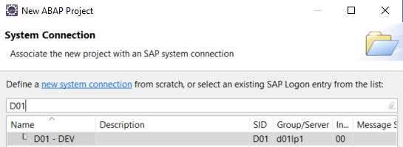

Click the next button. Verify the connection settings and click on the next button again.

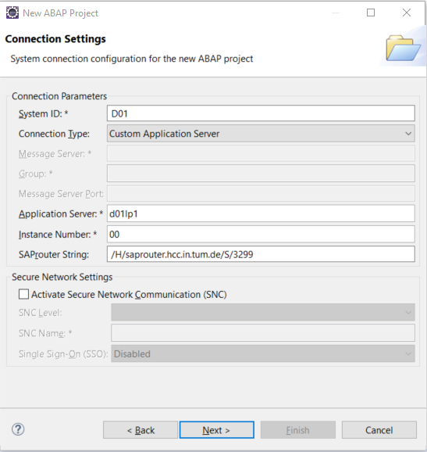

Enter the client number, username and password according to the information you received from your instructor and click next (instead of finish!).

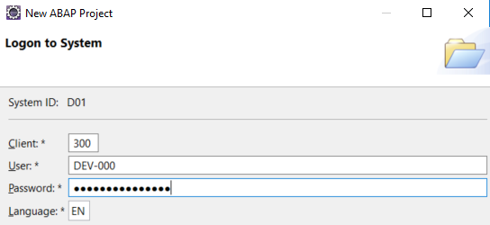

Enter Z_$$_### as project name. Please use the information provided by your instructor to replace $$ and ###. Afterwards click on finish to add finally your project to your Project Explorer.

Task 2: Create a new package and add the package to the favorites
Short description: Creation of a new package that contains the first ABAP developments as well as a new transport request. Afterwards the newly created package will be added to the favorite packages in Eclipse.

Make sure you are in the ABAP view. If not, use following menu path to change into the ABAP view:

Window • Perspective • Open Perspective • Other…

Afterwards select ‘ABAP’ and click OK.

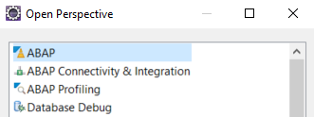

Open the integrated SAP GUI by clicking on the Button. Select the newly created Project Z_$$_### and click OK.

Please start the package builder by using transaction code SE21. Enter the transaction code in the according field in the integrated SAP GUI and press Enter or click the button..

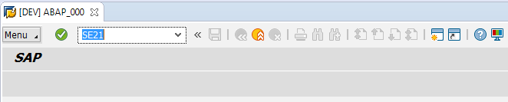

Please select “Package” and enter the name of your own package. Call the package Z_$$_###. Please use the information provided by your instructor to replace $$ and ###.

Package builder
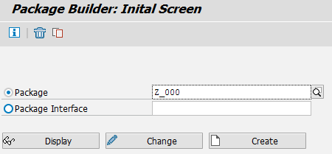

Click the “Create” button to create your package. The system will ask you for further information. Enter a short text which describes your package.

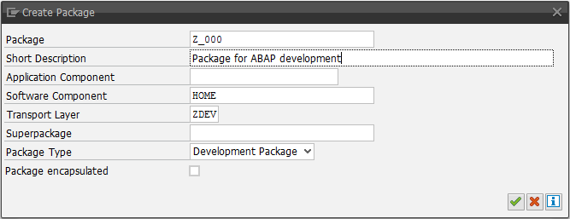
Enter a short text

Create a new request
After you hit ‘Enter’ or alternatively click on the green checkmark, the system will ask you for a transport request. As you do not have a request yet, we are going to create a new request now. Use the ‘Create Request’ button with the empty white page icon or press alternatively F8.

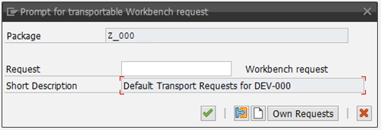

Type in a short text to describe your new request and leave all other fields as they are. Click the save icon to create your request.

Enter a short text
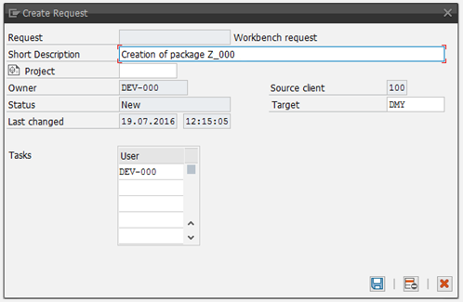

Confirm the usage of your newly created request by clicking the continue button (green checkmark) or simply press ‘Enter’.

Finally, you have created a new package that can be used to hold your future ABAP developments.

You can close the integrated SAP GUI by pressing the close button .

Add the newly created package to your favorites in Eclipse by performing a right click on “Favorite Packages” and selecting “Add a Package…” afterwards.

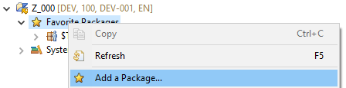

Now enter the name of your package, select your package and confirm your selection with ok.

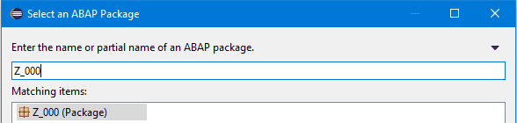

Task 3: Create a new program Z_$$_###_HELLOWORLD
Short description: The aim of the task is to create your first ABAP program and to release your task and request
Package name ok?

Use the right mouse button on the newly created package (Z_$$_###) to create a program. From the context menu choose:
Context Menu path

New • ABAP Program

Eclipse asks you for a program name and a short description. Call your program ‘Z_$$_###_HELLOWORLD’. Please use the information provided by your instructor to replace $$ and ###.

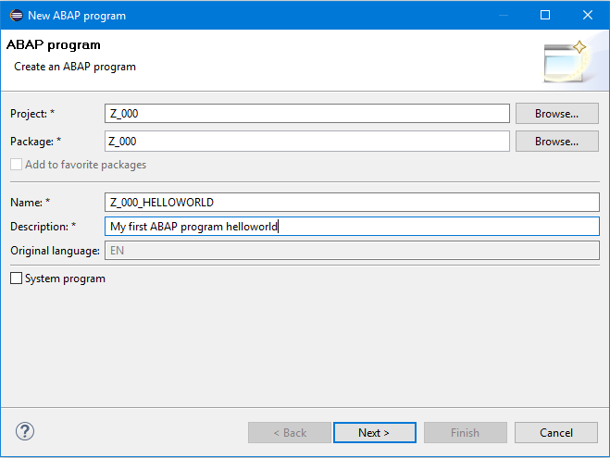

In the following screen please select ‘create a new request’ when being asked for a transport request and enter a short description.
Create a new request

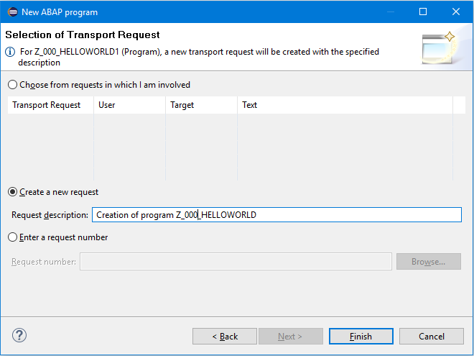
Add the line ‘write 'Hello World!' to your program. Please pay attention to the dot at the end of the line as this indicates the end of the current line. The dot in ABAP is similar to the semicolon in Java or C#.

First statement
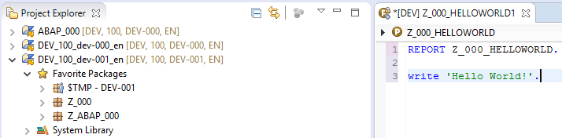

Now save your new program using the save icon or use following menu path:
Save, check and activate

File • Save

The button allows you to check your ABAP code. You can activate your program now using the button. Please keep in mind: without activation you will be using the last activated version of your program! So don’t forget to activate your program after you made changes.
Run your program now by clicking . When being asked select ‘ABAP Application’ as the way to run your program and click ok.

Run Program
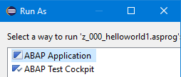

An embedded SAP GUI window will now be shown in Eclipse with the result of your program.

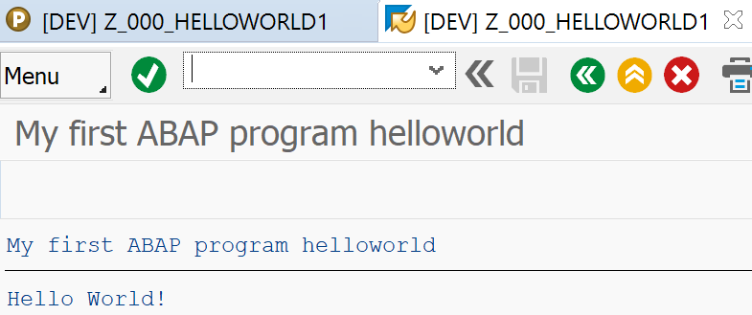

Transport organizer
Now in the last step of the task we want to release our first program for transportation to other SAP systems. Open the integrated SAP GUI now again by pressing the button. Call the Transport Organizer by using transaction code SE09.

Please type in your username into the User input field (if it is not already) and deselect the Customizing Request checkbox. Now hit Enter.

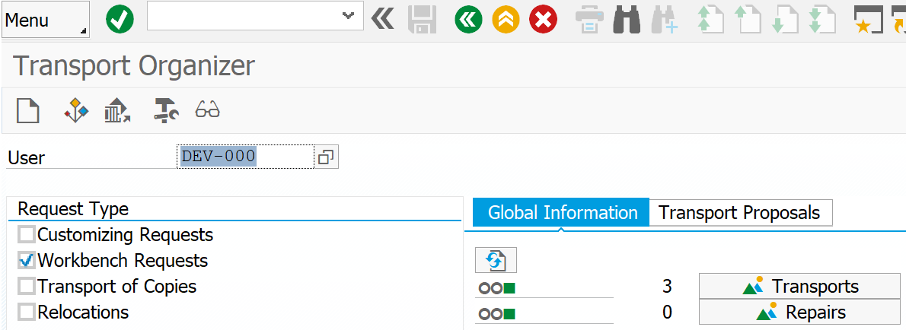

Expand request
The Transport Organizer shows all of your transport requests. You should see the request for your new package as well as the request for your first program. Expand the request node for your program by pressing the ‘Plus’ symbol on the left side. The request contains the development of one program which is named Z_$$_###_HELLOWORLD. The development of the program is assigned to a task. The task itself is assigned to the request. A request may contain many tasks for different developers.

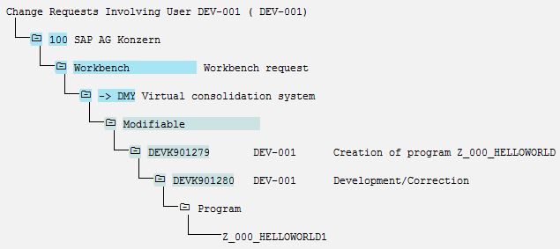

Release task and request
In the last step you will release your request now. Therefore, in a first step the task has to be released. To do so, use your right mouse button and click on the task. Select ‘Release Directly’ from the context menu. After the task is released you can go on and release the request. Click with the right mouse button on the request and select ‘Release Directly’ from the context menu.

The SAP system now creates the export of the transport request so that the developments are available to other SAP systems. This may take a few seconds. It is necessary to refresh the display. To refresh the display please use menu path:

Edit • Refresh

Or click the refresh button . After successful completion your screen should look similar to this:

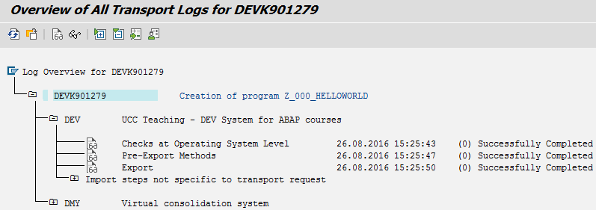

Request and task released
In the Transport Organizer you may have a look on your transport requests again and you will notify that your request and your task are released now. A released request as well as a released task cannot be edited or changed anymore. So if you want further developments to your new programs you will have to create another transport request.
